Task Description#1  
● Zero-shot: Prompt AI to write a function that checks whether a given year is a leap  
year.  
Expected Output#1  
● AI-generated function with no examples provided

Code:

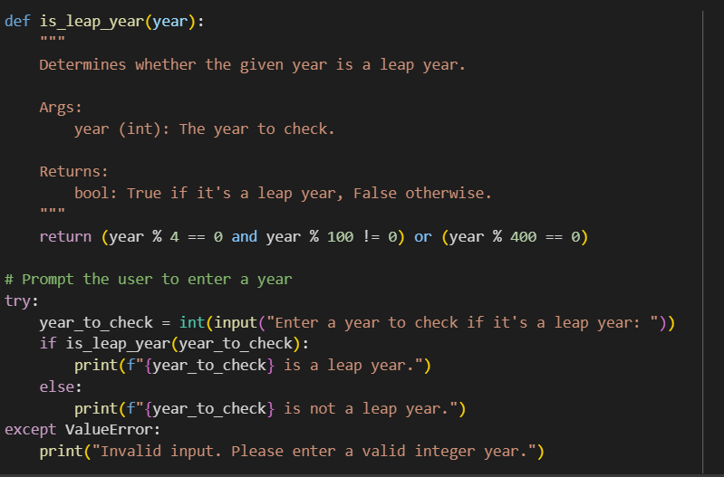

Output:  
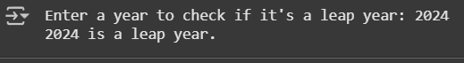

Explanation:

Leap Year Logic – Explanation A leap year occurs to keep our calendar aligned with Earth's orbit around the sun. The rules are: - A year is a leap year if it is divisible by 4 but not divisible by 100, unless it is also divisible by 400. This means: - Years like 2024 and 2000 are leap years. - Years like 1900 and 2100 are not leap years. The Python function uses this logic: def is_leap_year(year): return (year % 4 == 0 and year % 100 != 0) or (year % 400 == 0) Explanation: - year % 4 == 0 → checks if the year is divisible by 4. - year % 100 != 0 → excludes century years unless... - year % 400 == 0 → ...they’re divisible by 400, which makes them leap years. This compact boolean expression ensures accurate leap year detection with minimal code.